Practical : 20

## Aim: Create a webpage, that allows user to add a new username if user doesn’t exist in the database. Also create a forgot password link, to redirect user to set up his new password on authentication

Login.aspx

<%@ Page Language="vb" AutoEventWireup="false" CodeBehind="Login.aspx.vb" Inherits="Practical_20.Login" %>

<!DOCTYPE html>

<html xmlns="http://www.w3.org/1999/xhtml">

<head runat="server">

<title></title>

</head>

<body>

<form id="form1" runat="server">

<div>

<strong>Login</strong><br />

<br />

Username :

<asp:TextBox ID="txtUsername" runat="server"></asp:TextBox>

<br />

<br />

Password :

<asp:TextBox ID="txtPwd" runat="server" TextMode="Password"></asp:TextBox>

&nbsp;<br />

<br />

<asp:Button ID="btnCreateAccount" runat="server" Text="Register Yourself" />

<asp:Button ID="btnForgotPassword" runat="server" Text="Forgot Password" />

<br />

<br />

<asp:Button ID="btnLogin" runat="server" Text="Login" />

</div>

</form>

</body>

</html>

Login.aspx.vb

Public Class Login

Inherits System.Web.UI.Page

Protected Sub Page_Load(ByVal sender As Object, ByVal e As System.EventArgs) Handles Me.Load

End Sub

Protected Sub btnLogin_Click(sender As Object, e As EventArgs) Handles btnLogin.Click

Dim con As New SqlClient.SqlConnection("Data Source=(LocalDB)\MSSQLLocalDB;AttachDbFilename=C:\Users\ISHAN\Desktop\Databases\Info.mdf;Integrated Security=True;Connect Timeout=30")

Dim ad As New SqlClient.SqlDataAdapter("select * from tblLogin where username = '" & txtUsername.Text & "' and password = '" & txtPwd.Text & "' ", con)

Dim ds As New DataSet

con.Open()

ad.Fill(ds)

con.Close()

If ds.Tables(0).Rows.Count > 0 Then

Response.Redirect("Home.aspx")

Else

Response.Write("<font color='red'>Invalid Username/Password</font>")

End If

End Sub

Protected Sub btnCreateAccount_Click(sender As Object, e As EventArgs) Handles btnCreateAccount.Click

Response.Redirect("Register.aspx")

End Sub

Protected Sub btnForgotPassword_Click(sender As Object, e As EventArgs) Handles btnForgotPassword.Click

Response.Redirect("ForgotPassword.aspx")

End Sub

End Class

Register.aspx

<%@ Page Language="vb" AutoEventWireup="false" CodeBehind="Register.aspx.vb" Inherits="Practical_20.Register" %>

<!DOCTYPE html>

<html xmlns="http://www.w3.org/1999/xhtml">

<head runat="server">

<title></title>

</head>

<body>

<form id="form1" runat="server">

<div>

<strong>Register<br />

</strong>

<br />

Username :

<asp:TextBox ID="txtUsername" runat="server"></asp:TextBox>

<br />

<br />

Password :

<asp:TextBox ID="txtPwd" runat="server" TextMode="Password"></asp:TextBox>

<br />

<br />

Confirm Password :

<asp:TextBox ID="txtCpwd" runat="server" TextMode="Password"></asp:TextBox>

<br />

<br />

Hint :

<asp:TextBox ID="txtHint" runat="server"></asp:TextBox>

<br />

<br />

<asp:Button ID="btnRegister" runat="server" Text="Register" />

<br />

<br />

<asp:Button ID="btnBackToLogin" runat="server" Text="Back to Login" />

</div>

</form>

</body>

</html>

Register.aspx.vb

Public Class Register

Inherits System.Web.UI.Page

Protected Sub Page_Load(ByVal sender As Object, ByVal e As System.EventArgs) Handles Me.Load

End Sub

Protected Sub btnRegister_Click(sender As Object, e As EventArgs) Handles btnRegister.Click

Dim con As New SqlClient.SqlConnection("Data Source=(LocalDB)\MSSQLLocalDB;AttachDbFilename=C:\Users\ISHAN\Desktop\Databases\Info.mdf;Integrated Security=True;Connect Timeout=30")

Dim cmd As New SqlClient.SqlCommand("insert into tblLogin values('" & txtUsername.Text & "','" & txtPwd.Text & "','" & txtHint.Text & "')", con)

Dim ds As New DataSet

con.Open()

cmd.ExecuteNonQuery()

con.Close()

Response.Write("Profile Creater Successfully !!")

Response.Redirect("Login.aspx")

End Sub

Protected Sub btnBackToLogin_Click(sender As Object, e As EventArgs) Handles btnBackToLogin.Click

Response.Redirect("Login.aspx")

End Sub

End Class

ForgotPassword.aspx

<%@ Page Language="vb" AutoEventWireup="false" CodeBehind="ForgotPassword.aspx.vb" Inherits="Practical_20.ForgotPassword" %>

<!DOCTYPE html>

<html xmlns="http://www.w3.org/1999/xhtml">

<head runat="server">

<title></title>

</head>

<body>

<form id="form1" runat="server">

<div>

<strong>Forgot Password</strong><br />

<br />

Enter Username :

<asp:TextBox ID="txtUsername" runat="server"></asp:TextBox>

<br />

<br />

<asp:Button ID="btnShowHint" runat="server" Text="Show Hint" />

<br />

<br />

<asp:Label ID="lblHint" runat="server" Text=""></asp:Label>

<br />

<br />

<asp:Button ID="btnBackToRegister" runat="server" Text="Back to Register" />

<asp:Button ID="btnBackToLogin" runat="server" Text="Back to Login" />

</div>

</form>

</body>

</html>

ForgotPassword.aspx.vb

Public Class ForgotPassword

Inherits System.Web.UI.Page

Protected Sub Page_Load(ByVal sender As Object, ByVal e As System.EventArgs) Handles Me.Load

End Sub

Protected Sub btnShowHint_Click(sender As Object, e As EventArgs) Handles btnShowHint.Click

Dim con As New SqlClient.SqlConnection("Data Source=(LocalDB)\MSSQLLocalDB;AttachDbFilename=C:\Users\ISHAN\Desktop\Databases\Info.mdf;Integrated Security=True;Connect Timeout=30")

Dim ad As New SqlClient.SqlDataAdapter("select * from tblLogin where username='" & txtUsername.Text & "' ", con)

Dim ds As New DataSet

con.Open()

ad.Fill(ds)

con.Close()

If ds.Tables(0).Rows.Count > 0 Then

lblHint.Text = ds.Tables(0).Rows(0).Item("hint").ToString

Else

Response.Write("<font color=red>Invalid Username</font>")

End If

End Sub

Protected Sub btnBackToLogin_Click(sender As Object, e As EventArgs) Handles btnBackToLogin.Click

Response.Redirect("Login.aspx")

End Sub

Protected Sub btnBackToRegister_Click(sender As Object, e As EventArgs) Handles btnBackToRegister.Click

Response.Redirect("Register.aspx")

End Sub

End Class

Home.aspx

<%@ Page Language="vb" AutoEventWireup="false" CodeBehind="Home.aspx.vb" Inherits="Practical_20.Home" %>

<!DOCTYPE html>

<html xmlns="http://www.w3.org/1999/xhtml">

<head runat="server">

<title></title>

</head>

<body>

<form id="form1" runat="server">

<div>

Welcome To Home Page of Ishan's Website..!!

</div>

</form>

</body>

</html>

Output :

Empty Database :

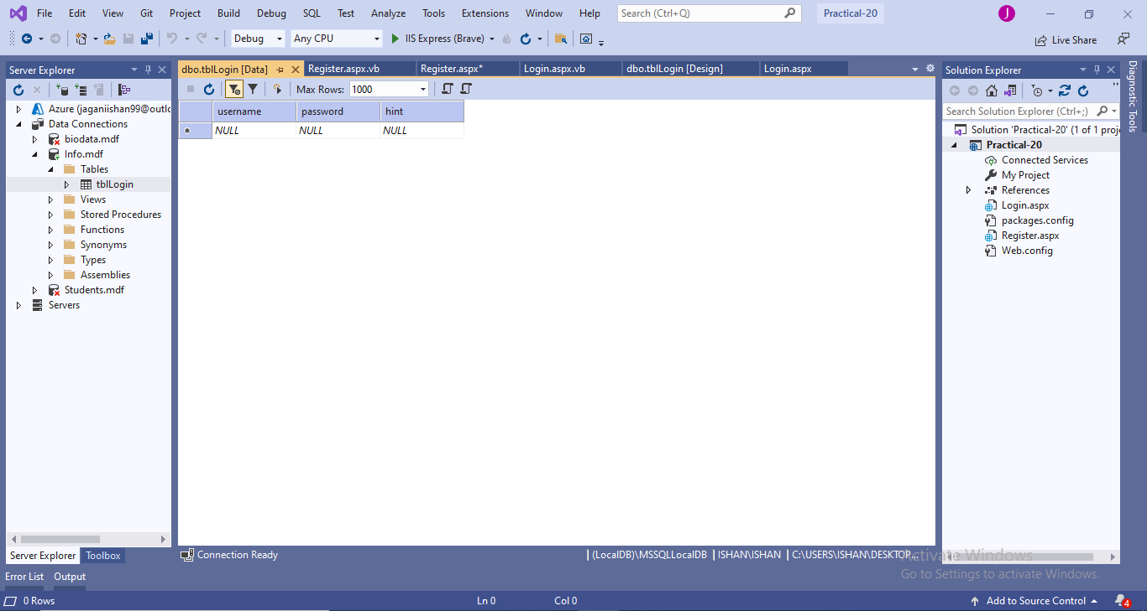

Registration :

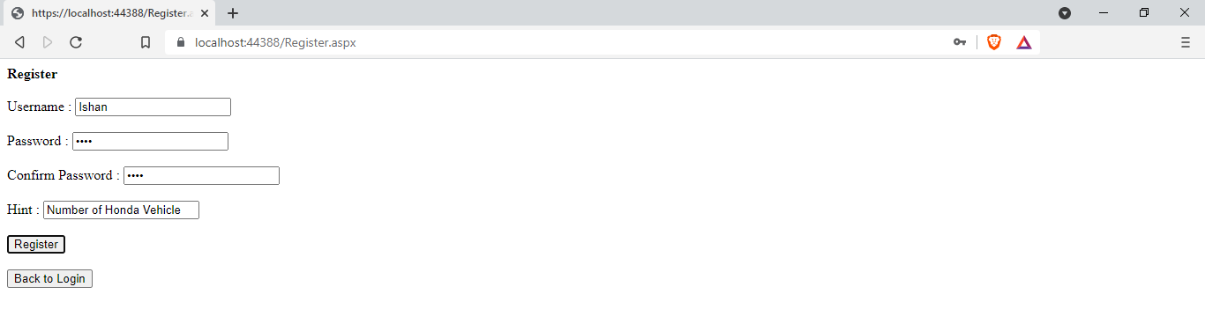

After Registration :

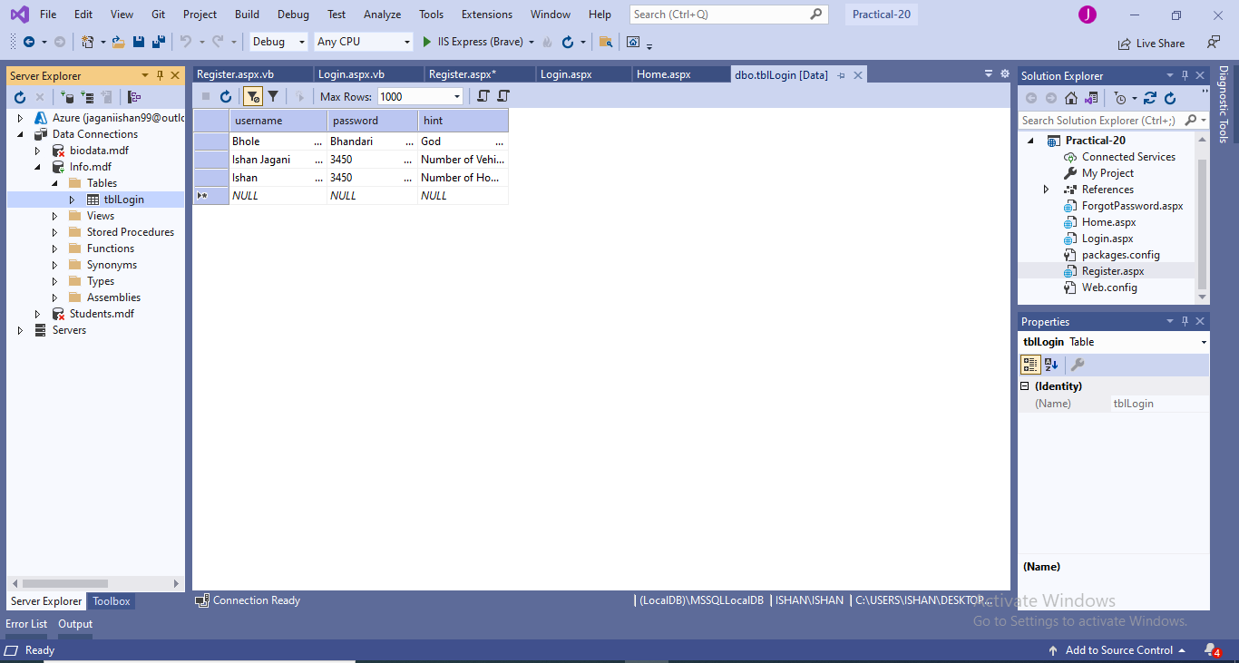

Login:

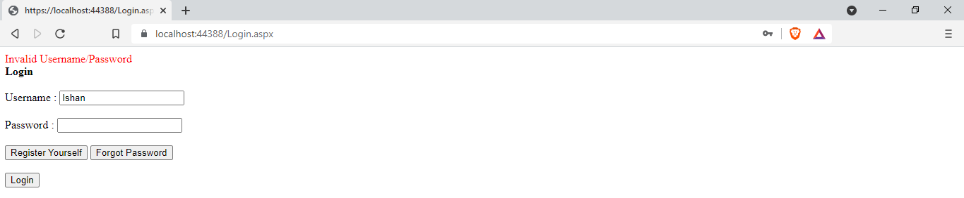

On Successful Login:



Forgot Password:

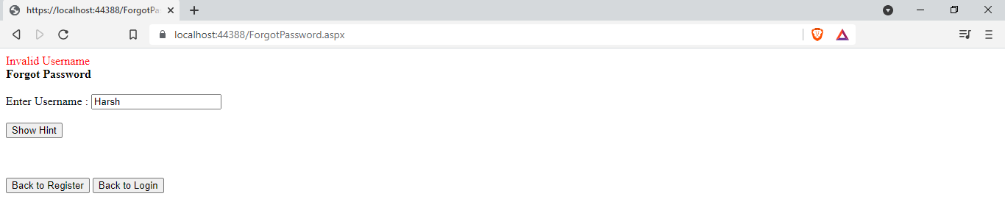

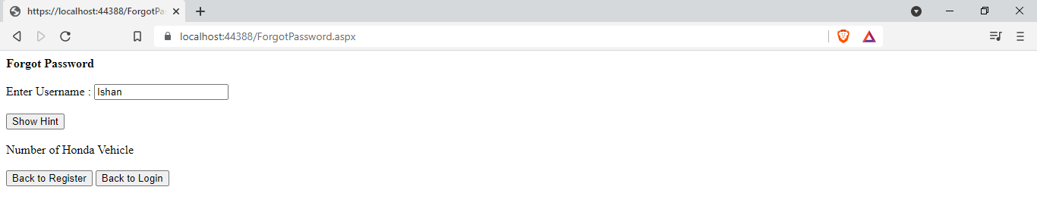

|  |  |  |  |
| --- | --- | --- | --- |
| Start Date | End/Sign Date | Faculty Sign | Remarks/Grade |
|  |  |  |  |